Cyber Security
Assignment Day 4
Question 1:
Find out the mail servers of the following domain:
- Ibm.com
- Wipro.com
Ans:
Definition of mail server
Within the Internet email system, a message transfer agent or mail transfer agent or mail relay is software that transfers electronic mail messages from one computer to another using SMTP.
Open PenTester VMware workstation
Open Command Prompt
Type:
ipconfig
nslookup
www.Ibm.com
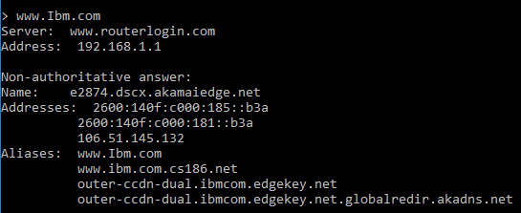
www.Wipro.com
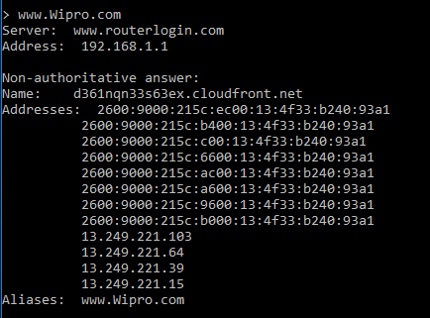
Question 2:
Ans:
Find the locations, where these email servers are hosted.
Cont. of Question 1
Type:
set type=mx
Ibm.com
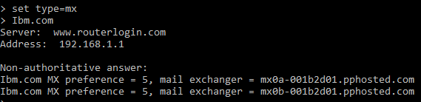
Open google chrome
Open IP Location Finder
Copy paste the url and find the location
Address 1:
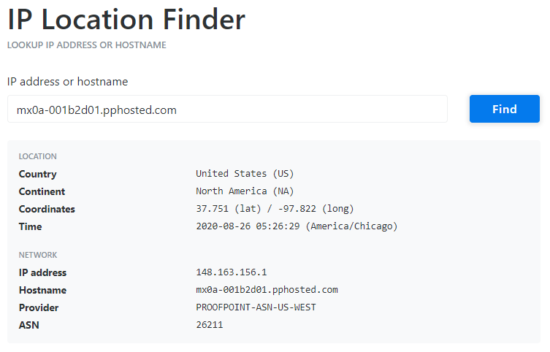
Address 2:
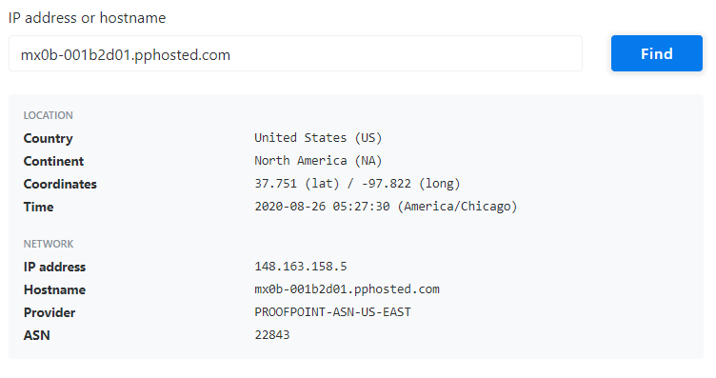
Wipro.com
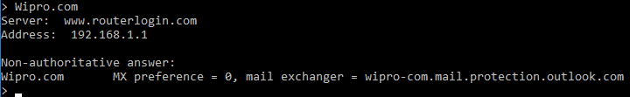
Open google chrome
Open IP Location Finder
Copy paste the URL and find the location
Address:
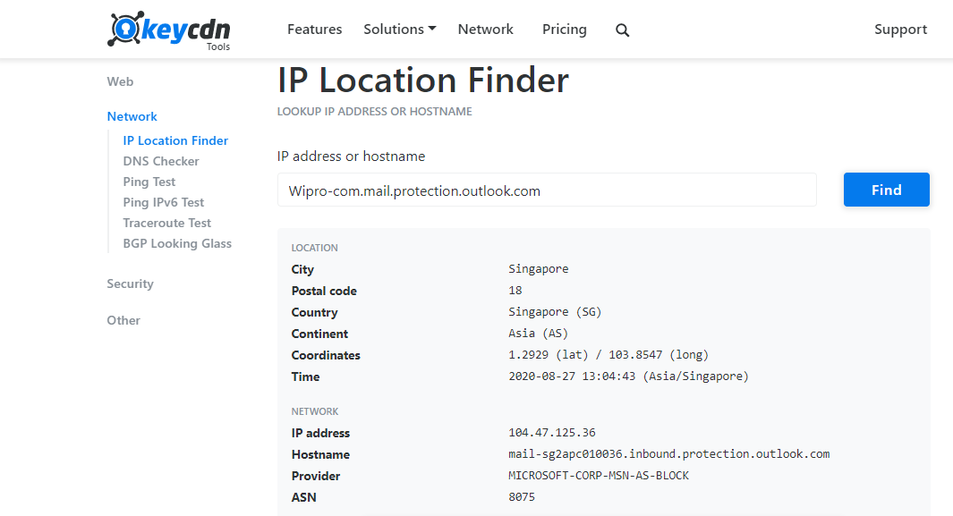
Question 3:
Ans:
Scan and find out port numbers open 203.163.246.23

Open Kali-pc
Right click on the screen and Open Terminal

Type:
sudo su –
Enter password
Enter – nmap –Pn –sS 203.163.246.23

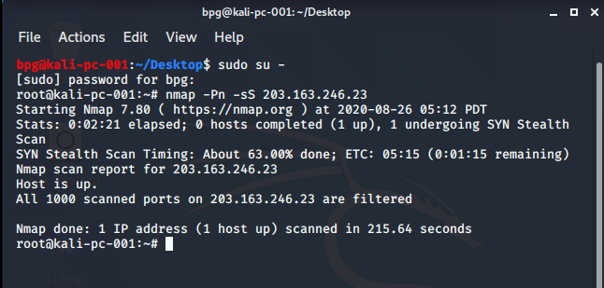

As it is coming filtered due to firewall protection we try some other ways of breaking the firewall
Enter: -sS -v -v -Pn 203.163.246.23
For me it is still coming filtered so I’ll further use the following command
Enter: nmap -6 203.163.246.23
Again it is coming filtered for me so I’ll further use the following command
Enter: nmap -p 22,25,135 -Pn -v –b 203.163.246.23 scanme.nmap.org
Again it is coming filtered for me so I’ll further use the following command
Enter: nmap -vv -n -sS -Pn --ip-options "L 203.163.246.23 " --reason 203.163.246.23
Now I get only one port open as shown below
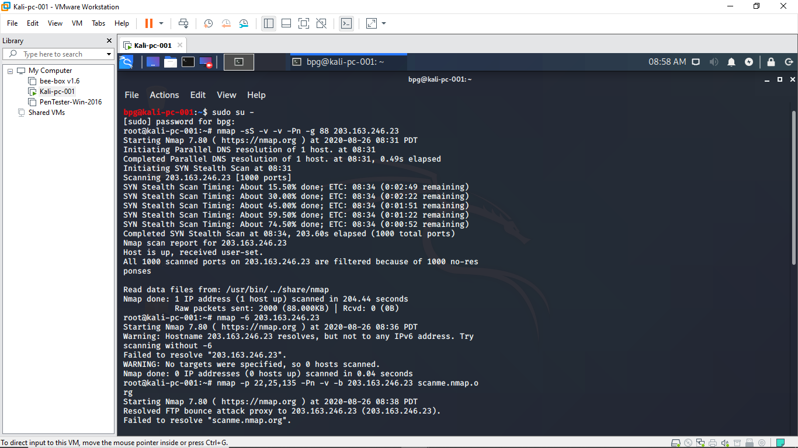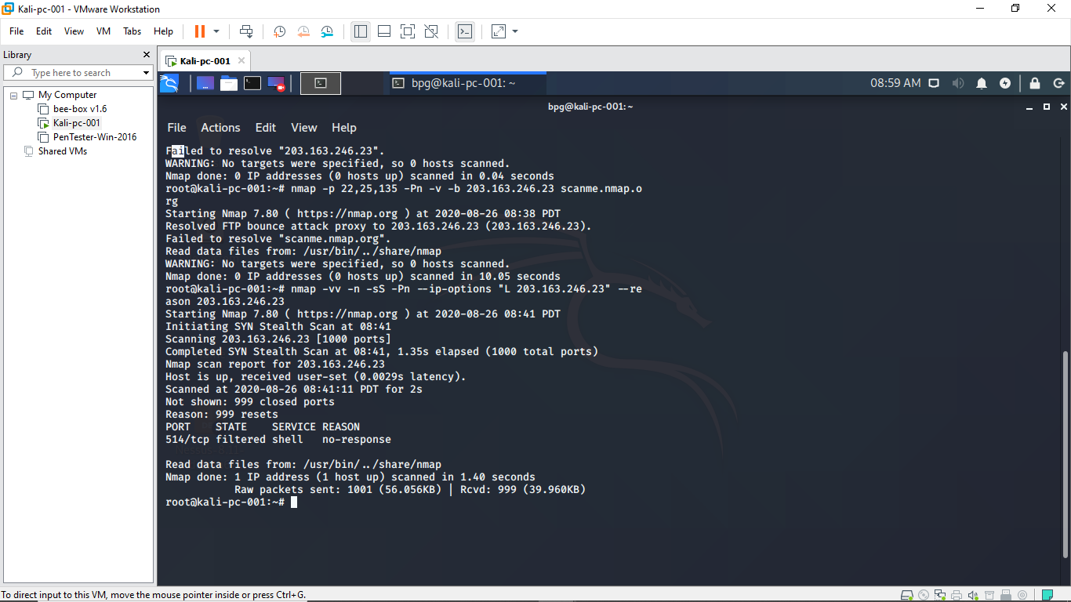

So out of the 1000 ports in the given ip address I get only 1 port open which is 514/tcp
Hence I conclude that only one port is open from the scanned ports
Question 4:
Install nessus in a VM and scan your laptop/desktop for CVE
Ans:
First of all we go to the essentials page in google chrome in the vm we are using (pentester in my case) then generate the activation code
Next we download nessus for windows server 2016 according to the requirement of the virtual machine
Then in the downloaded files go to web client and put the activation key generated via email allow it to download and compile the files required
Then we click on new scan and select advanced scan and type the name of the scan ex: pentester scan and next we click on credentials and put the username and password of the virtual machine
Then we will launch the scan and wait for the completion of scan which takes few minutes as shown below
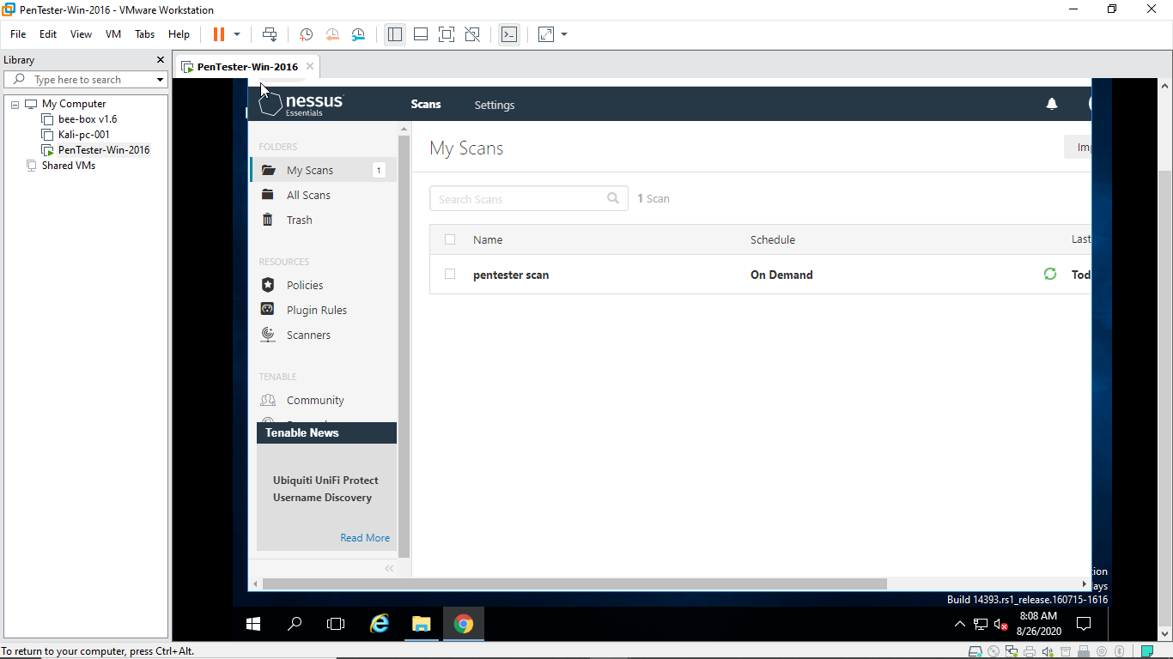
finally after completion of scan it will show no of vulnerabilities and host as well as scan history as shown below
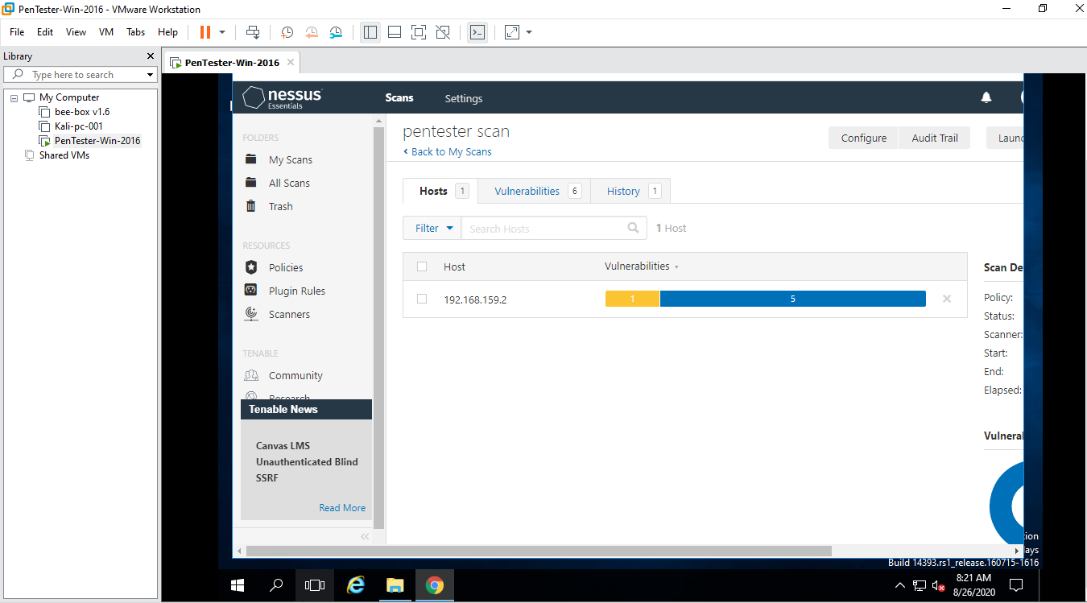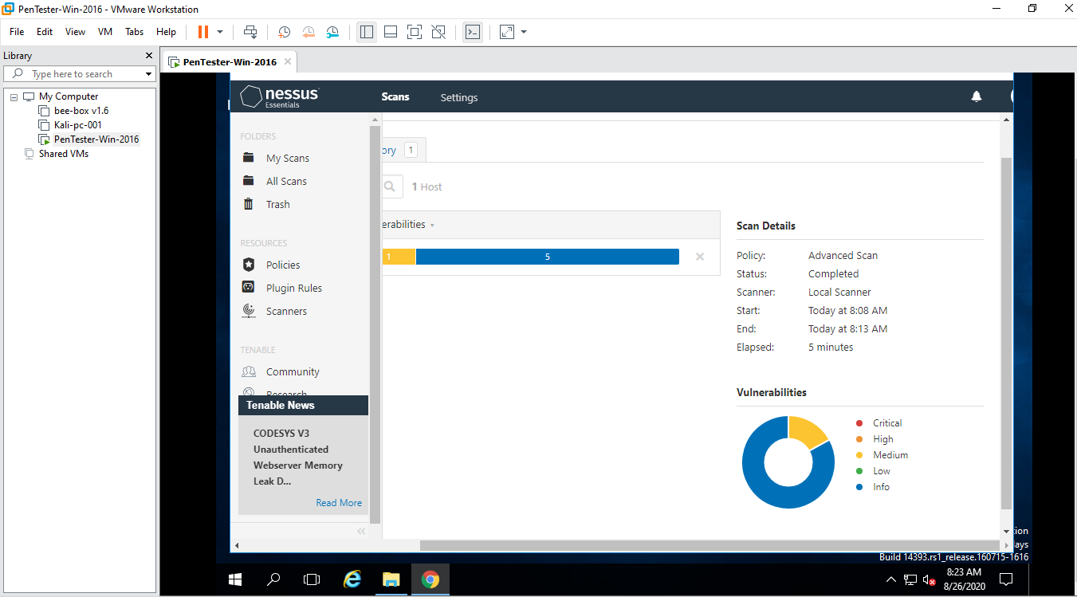

As u can see my ip address shows 6 vulnerabilities of which 5 are info and 1 is medium
Details of vulnerabilities are as shown below
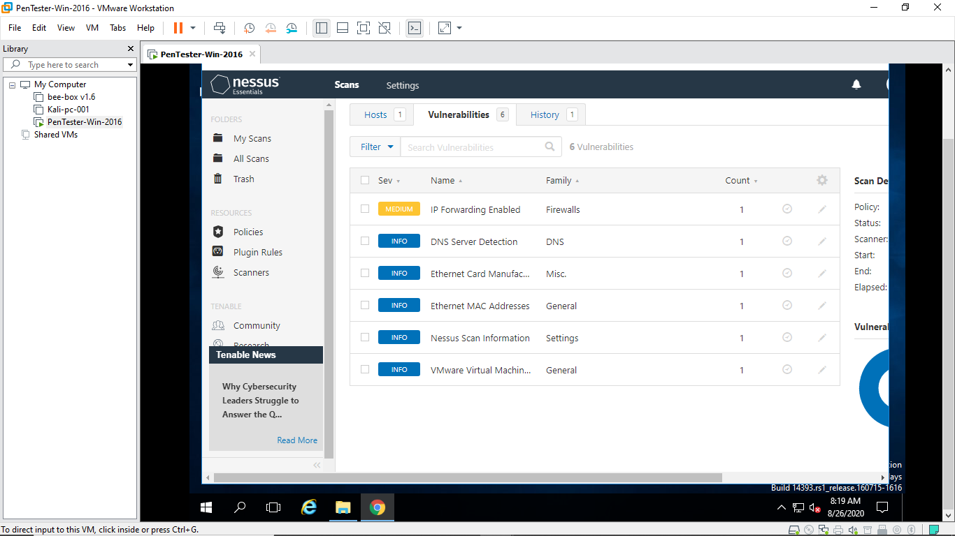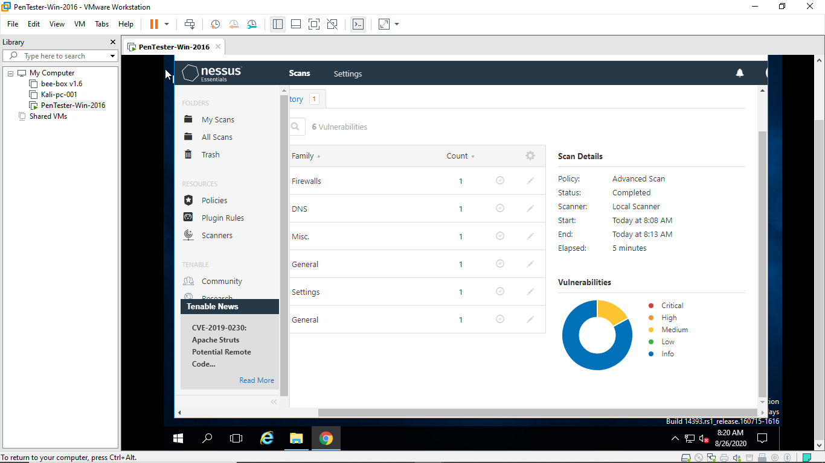
Now what do they mean and what is this nessus vulnerability scan how to resolve these vulnerabilities can be defined as given below
Vulnerability scan
Vulnerability scanning is an inspection of the potential points of exploit on a computer or network to identify security holes.
A vulnerability scan detects and classifies system weaknesses in computers, networks and communications equipment and predicts the effectiveness of countermeasures. A scan may be performed by an organization’s IT department or a security service provide, possibly as a condition imposed by some authority. An Approved Scanning Vendor (ASV), for example, is a service provider that is certified and authorized by the Payment Card Industry (PCI) to scan payment card networks. Vulnerability scans are also used by attackers looking for points of entry.
Meaning of various levels of vulnerability
To help you better decide which vulnerabilities should be fixed first, Nessus categorizes them using risk scores in its scans and reports. There are five vulnerability levels:
- Critical ()
- High ()
- Medium ()
- Low ()
- Information Alerts ().
There is one additional types of alerts: Best Practice

Critical Severity Web Vulnerabilities
This section explains how we define and identify web vulnerabilities of Critical severity ().
The issues marked as Critical Severity can allow attackers to execute code on the web application or application server, or access sensitive data.

Impacts of Critical Severity Web Vulnerabilities
- Examples include SQL Injection, Remote Code Execution and Command Injections. In exploiting this type of vulnerability, attackers could carry out a range of malicious acts that could, for example, affect an web application's availability, or put its confidentiality and security at risk.
- In addition, it is the existence and prevalence of automated exploitation tools that make fixing these types of issues urgent.

Suggested Action for Critical Severity Vulnerabilities
A Critical severity vulnerability means that your website is at risk of being hacked at any time. We recommend that you make it your highest priority to fix these vulnerabilities immediately.
As u can see from the above screenshots I have no critical severity

High Severity Web Vulnerabilities
This section explains how we define and identify web vulnerabilities of High severity ().
The issues marked as High Severity can allow malicious attackers to access application resources and data. This can allow an attacker to steal session information or sensitive data from the application or server.
The difference between a Critical and High Severity is that with a High Severity vulnerability, a malicious attacker cannot execute code or a command on the application or server.

Impacts of High Severity Vulnerabilities
- In the case of a detected XSS vulnerability, an attacker could: Examples include XSS, XML External Entity Injection and LFI.
- Execute script code in the user's browser
- Steal the user's cookies
In the case of a detected XXE vulnerability, an attacker could:
- Read sensitive data in the server
- Make requests to internal or external resources
- Attackers conducting this type of attack have some technical skills, but many tools make the exploitation process automated.

Suggested Action for High Severity Vulnerabilities
A High severity vulnerability means that your website can be hacked and can lead hackers to find other vulnerabilities which have a bigger impact. We recommend that you fix these types of vulnerabilities immediately.
As u can see in above screenshots I don’t have any high severity vulnerabilities

Medium Severity Web Vulnerabilities
This section explains how we define and identify vulnerabilities of Medium severity ().
The issues marked as Medium Severity usually arise because of errors and deficiencies in the application configuration. By exploiting these security issues, malicious attackers can access sensitive information on the application or server.
In comparison to Critical and High Severity issues, the impact is relatively limited.

Impacts of Medium Severity Vulnerabilities
- Attackers conducting this type of attack require more skill than those exploiting Critical and High Severities.
- Exploitation of these types of vulnerabilities can depend on the existence of some special conditions. For example, in the case of SSL/TLS certificate issues, or misconfiguration of TLS, an attacker has to be in an appropriate location to be able to eavesdrop on the connection of the victim

Suggested Action for Medium Severity Vulnerabilities
Even though special conditions are required to exploit Medium Severity issues and they don't directly affect the application or system (in contrast to Critical and High Severities), in order to keep your web application secure and comply with the regulations, they should still be fixed.
.
As u can see I have 1 medium vulnerability that is ip forwarding is enabled so I have to disable it

Low Severity Web Vulnerabilities
This section explains how we define and identify web vulnerabilities of Low severity ().
The issues marked as Low Severity include information leakage, configuration errors and a lack of some security measures. They can be combined with other issues of a higher severity level, and can be used in conjunction with social engineering (manipulating people into following certain actions or revealing crucial information), to cause a more severe impact on the target.
In comparison to Critical, High and Medium Severity issues, these findings have limited effect.

Impacts of Low Severity Vulnerabilities
- When a website reveals the version number of an application, an attacker can carry out Vulnerability Mapping by looking at the vulnerability database to see if an issue exists in that version of the application and then exploiting it.
- Nessus reports Username Disclosure vulnerabilities when related to Windows or Linux operating systems or RDBMS. Though they are flagged as low level vulnerabilities by themselves, an attacker could use this information to find a way to access the target application's operating system or database system.
- In the case of application configuration errors and deficiencies such as an X-Frame-Options header (XFO) – which controls whether a website is loaded by itself, another site or neither – Nessus reports a missing XFO if the scanned web application does not set, or mistakenly sets, the XFO header. An attacker could exploit these configuration errors by convincing an authorized user to click on a malicious link or button (a potentially state-changing operation), that could result in the deletion or records or uncover hidden resources.

Suggested Action for Low Severity Vulnerabilities
A decision on whether to fix these issues should be determined by assessing the context in the application, and by considering the business impacts.
As u can see from the screenshots I have no low severity vulnerabilities

Best Practice
This section explains how we define and identify issues that are marked as Best Practice ().
Making web applications secure involves more than taking rapid action on detected vulnerabilities. Browser vendors offer various features that make being proactive easier than ever. These preemptive standards and recommendations help software developers make web applications that are secure by design.

Impacts of Best Practice Issues
- The issues marked as Best Practice are recommendations, not vulnerabilities. Examples include Content Security Policy, Referrer-Policy, Expect-CT, Subresource Integrity – security implementations that are provided by browser vendors. Think of these recommendations as an extra security layer, defence in depth, to help continually contribute to the security of your web applications – proactively.
- Nessus makes suggestions around these standards and reports errors and issues in the implementation of them.

Suggested Action for Best Practice Issues
Nessus recommends that these Best Practice suggestions are implemented in order to make your web application secure.
As u can see I don’t have any best practice alerts

Information Alerts
This section explains how we define and identify issues that are marked as Information Alerts ().
The findings reported are mostly for informing you about the target's ingredients and infrastructure. They help you to understand the application's technology stack and dependencies well.

Impacts of Information Alerts
- The issues highlighted in these alerts can help attackers understand the target more and therefore tailor their attack better, eliminate other possibilities and conduct vulnerability mapping.
- For example, revealing that a website uses a certain IIS version does not seem that important at first sight. However, it means that the OS of the target web application is a Windows OS, for example. So, an attacker can eliminate attack possibilities regarding other operating systems. In addition, vendors who use IIS tend to prefer application infrastructures offered by Microsoft. An attacker could reasonably assume that the target application was developed using either ASP or .NET technologies. This can further help them eliminate other attack possibilities regarding other application infrastructure and save time.
- In the case of vulnerability mapping, if the target uses older versions of IIS that have known security issues, this can allow a target machine to be compromised by an attacker. For instance CVE-2017-7269 was an issue in IIS 6.0 and exploited since 2016. It allows remote attackers to execute arbitrary code in the target. (Please note that in the case of an out-of-date component, and an associated vulnerability, this would be reported at a higher level than Information Alert.

Suggested Action for Information Alerts
Most of the time, there is no need to take any action for Information level findings. This is why Nessus Essentials marks them as Accepted Risk.
However, Nessus recommends that you manually review Information Alert level findings and modify the application to avoid revealing details that give hints or information regarding the application itself.
As u can see I have 5 information alerts on dns server detection, Ethernet card manufacturing, Ethernet mac address,Nessus scan information and vm ware virtual machine so I need not be worried but at the same time have to resolve these vulnerabilities
Last history is given showing the history of the scan like timings date time elapsed etc as shown below

